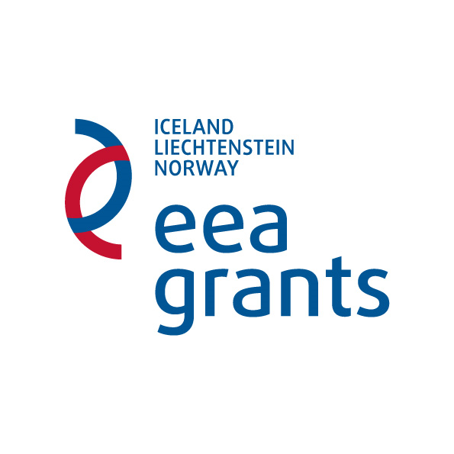
EEA Financial Mechanism 2009–2014
to the Programme LT08
“EEA scholarship programme”

PREPARATORY VISITS UNDER BILATERAL FUND

ANNEX 2

APPICATION SELECTION CRITERIA

Administrative criteria: | Yes | No
The application was submitted by the date indicated in the call.
The original application was submitted to the Ministry of Education and Science of the Republic of Lithuania by registered mail or by courier.
The application complies with the established application form.
The application is completed properly.
The application is signed by head of applicant’s institution or authorized person by him, and by participant of preparatory visit.
Application sheets are properly numbered.
All documents mentioned in application are enclosed.
Electronic version is submitted by email indicated in the call.

Content related criteria: | Score  (0–3) | Justification for scores
Preparatory visit corresponds to the aims of EEA financial mechanism and Programme LT08 “EEA scholarship programme”.
Duration of preparatory visit is optimal.
Preparatory visit is purposeful, relevant and necessary for development of donor partnership project.

